School of Computer Science

Master of Applied computing (MAC)

Advanced Database Topic – COMP 8157 Section 4

**Lab 2: Partioning**

Prepared by

Rohit Kumar (110088741)

**--PART-1**

--1. Create a database <yourfirstname>vertical.

CREATE DATABASE Rohitvertical

Go

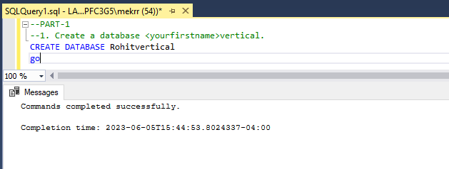

--2. Create a table “Product” table with the following columns: id, name, description, price, category, brand, and quantity.

--(Note: Insert 10 rows of data in this table)

CREATE TABLE Product

(

Id int IDENTITY (1,1) NOT NULL,

Name varchar (100),

Description varchar (100),

Price decimal(10,2),

Category varchar (20),

Brand varchar (20),

Quantity int

CONSTRAINT Product_PK PRIMARY KEY CLUSTERED (Id)

)

Go

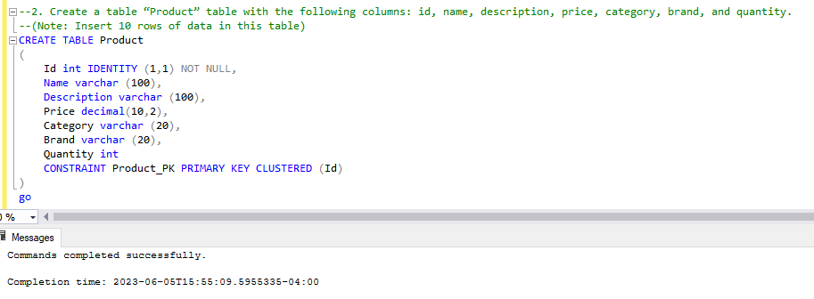

INSERT INTO dbo.Product(Name,Description, Price, Category, Brand, Quantity)

VALUES

('Farm Egg', 'Farm Egg by Fresco', 8.50, 'Dairy' , 'Fresco', 1),

('Bread', 'Bread by Costco', 2.50, 'Dairy' , 'Costco', 5),

('Rice', 'Basmati Rice by Food basics', 13.50, 'Food' , 'Food Basics', 3),

('Fam Curd', 'Farm Curd by Fresco', 4.50, 'Dairy' , 'Fresco', 2),

('Flour', 'Indian Flour by Walmart', 17.50, 'Food' , 'Walmart', 1),

('Body Lotion', 'Lotion by Jonhson', 7.00, 'Beauty' , 'Jonhson', 18),

('Jeans', 'Jeans by Zara', 22.50, 'Clothes' , 'Zara', 1),

('Chicken', 'Frozen Chicken by Fresco', 9.50, 'Dairy' , 'Fresco', 1),

('Shirt', 'Shirt by Lee', 12.50, 'Clothes' , 'Lee', 1),

('Shoes', 'Shoes by Nike', 21.50, 'Shoes' , 'Nike', 1)

Go

SELECT * FROM dbo.Product

Go

--3. Apply vertical partitioning by dividing the above table into two partition tables:

--i. “ProductBasic” table (Columns: id, name, description, and category)

--ii. “ProductDetails” table (Columns: id, price, brand, quantity)

CREATE TABLE ProductBasic

(

Id int FOREIGN KEY REFERENCES Product (Id),

Name varchar(100),

Description varchar (100),

Category varchar (20)

CONSTRAINT PK_ProductBasic PRIMARY KEY CLUSTERED (Id)

)

go

INSERT INTO dbo.ProductBasic(Id,Name, Description, Category)

VALUES

(1,'Farm Egg', 'Farm Egg by Fresco', 'Dairy'),

(2,'Bread', 'Bread by Costco', 'Dairy'),

(3,'Rice', 'Basmati Rice by Food basics', 'Food'),

(4,'Fam Curd', 'Farm Curd by Fresco','Dairy'),

(5,'Flour', 'Indian Flour by Walmart', 'Food' ),

(6,'Body Lotion', 'Lotion by Jonhson','Beauty'),

(7,'Jeans', 'Jeans by Zara', 'Clothes'),

(8,'Chicken', 'Frozen Chicken by Fresco', 'Dairy'),

(9,'Shirt', 'Shirt by Lee', 'Clothes'),

(10,'Shoes', 'Shoes by Nike', 'Shoes')

Go

SELECT * FROM dbo.ProductBasic

Go

CREATE TABLE ProductDetails

(

Id int NOT NULL,

Price decimal(10,2),

Brand varchar (20),

Quantity int

CONSTRAINT PK_ProductDetails PRIMARY KEY CLUSTERED (Id)

)

Go

INSERT INTO dbo.ProductDetails(Id,Price, Brand, Quantity)

VALUES

(1,8.50, 'Fresco', 1),

(2,2.50, 'Costco', 5),

(3,13.50,'Food Basics', 3),

(4,4.50, 'Fresco', 2),

(5,17.50,'Walmart', 1),

(6,7.00, 'Jonhson', 18),

(7,22.50,'Zara', 1),

(8,9.50, 'Fresco', 1),

(9,12.50, 'Lee', 1),

(10,21.50,'Nike', 1)

go

SELECT * FROM dbo.ProductDetails

Go

--4. Calculate the query performance of each table by retrieving the same ‘id’ from three tables.

SET STATISTICS IO ON

SET STATISTICS TIME ON

SELECT Id

FROM dbo.Product

WHERE Id = 1

SET STATISTICS IO OFF

SET STATISTICS TIME OFF

Go

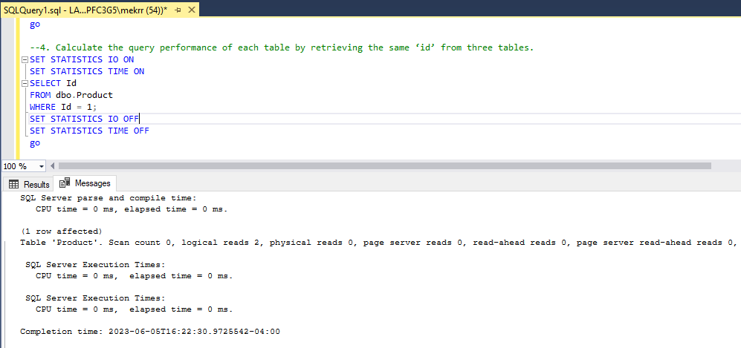

SET STATISTICS IO ON

SET STATISTICS TIME ON

SELECT Id

FROM dbo.ProductBasic

WHERE Id = 1

SET STATISTICS IO OFF

SET STATISTICS TIME OFF

Go

SET STATISTICS IO ON

SET STATISTICS TIME ON

SELECT Id

FROM dbo.ProductDetails

WHERE Id = 1

SET STATISTICS IO OFF

SET STATISTICS TIME OFF

Go

--5. Retrieve basic information of all products in a specific category from the “ProductBasic” table.

SELECT * FROM dbo.ProductBasic

WHERE

Category = 'Dairy'

Go

--6. Retrieve the price and brand of a specific product from the “ProductDetails” table.

SELECT Price, Brand FROM ProductDetails

WHERE

Brand = 'Fresco'

Go

**--PART-2**

--1. Create a database <yourfirstname>horizontal.

CREATE DATABASE Rohithorizontal

Go

--2. Create a table “Birthday” table with the following columns: s.no, name, date, month (01 - 06) and year.

--(Note: Insert 20 rows of data in this table)

INSERT INTO dbo.Birthday(Name, Date, Month, Year)

VALUES

('Rohit', 26, 7, 1990),

('Abhirup', 26, 4, 1991),

('Ratnakar', 16, 7, 1992),

('Rohan', 6, 8, 1993),

('Rahul', 31, 7, 1994),

('Rajesh', 30, 8, 1995),

('Deepak', 26, 2, 1996),

('Kunal', 26, 7, 1997),

('Virat', 22, 12, 1998),

('Anushka', 26, 11, 1999),

('Priyanka', 11, 7, 1990),

('Katrina', 15, 5, 1990),

('Salman', 17, 7, 1992),

('Remo', 26, 7, 1993),

('John', 12, 8, 1994),

('Jerry', 15, 8, 1995),

('Laura', 8, 9, 1996),

('Tom', 26, 7, 1997),

('Arun', 24, 7, 1998),

('Dhruv', 26, 8, 1999)

go

SELECT * FROM dbo.Birthday

Go

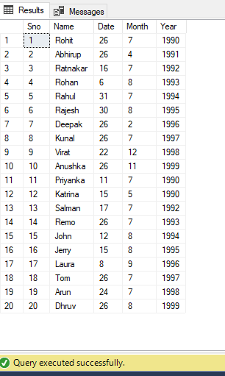

--3. Create filegroups within the database to divide them by month.

ALTER DATABASE Rohithorizontal ADD FILEGROUP January

go

ALTER DATABASE Rohithorizontal ADD FILEGROUP February

go

ALTER DATABASE Rohithorizontal ADD FILEGROUP March

go

ALTER DATABASE Rohithorizontal ADD FILEGROUP April

go

ALTER DATABASE Rohithorizontal ADD FILEGROUP May

go

ALTER DATABASE Rohithorizontal ADD FILEGROUP June

go

ALTER DATABASE Rohithorizontal ADD FILEGROUP July

go

ALTER DATABASE Rohithorizontal ADD FILEGROUP August

GO

ALTER DATABASE Rohithorizontal ADD FILEGROUP September

go

ALTER DATABASE Rohithorizontal ADD FILEGROUP October

go

ALTER DATABASE Rohithorizontal ADD FILEGROUP November

go

ALTER DATABASE Rohithorizontal ADD FILEGROUP December

Go

-- To show the created file group

SELECT data_space_id, name AS AvailableFilegroups, type_desc FROM sys.filegroups

WHERE type = 'FG'

Go

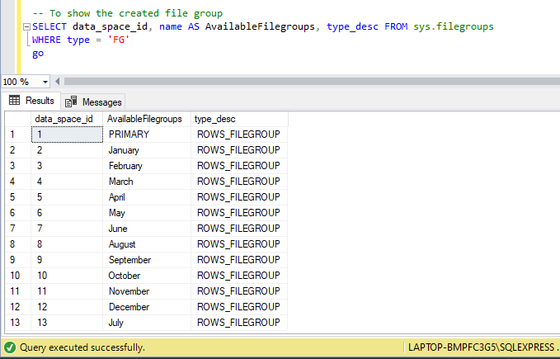

--Assigning hardware locations to partitions

ALTER DATABASE [Rohithorizontal]

ADD FILE

(

NAME = [Jan],

FILENAME = 'C:\Program Files\Microsoft SQL Server\MSSQL16.SQLEXPRESS\MSSQL\DATA\Rohithorizontal_1.ndf',

SIZE = 3072 KB,

MAXSIZE = UNLIMITED,

FILEGROWTH = 1024 KB

) TO FILEGROUP [January]

go

ALTER DATABASE [Rohithorizontal]

ADD FILE

(

NAME = [Feb],

FILENAME = 'C:\Program Files\Microsoft SQL Server\MSSQL16.SQLEXPRESS\MSSQL\DATA\Rohithorizontal_2.ndf',

SIZE = 3072 KB,

MAXSIZE = UNLIMITED,

FILEGROWTH = 1024 KB

) TO FILEGROUP [February]

go

ALTER DATABASE [Rohithorizontal]

ADD FILE

(

NAME = [Mar],

FILENAME = 'C:\Program Files\Microsoft SQL Server\MSSQL16.SQLEXPRESS\MSSQL\DATA\Rohithorizontal_3.ndf',

SIZE = 3072 KB,

MAXSIZE = UNLIMITED,

FILEGROWTH = 1024 KB

) TO FILEGROUP [March]

go

ALTER DATABASE [Rohithorizontal]

ADD FILE

(

NAME = [Apr],

FILENAME = 'C:\Program Files\Microsoft SQL Server\MSSQL16.SQLEXPRESS\MSSQL\DATA\Rohithorizontal_4.ndf',

SIZE = 3072 KB,

MAXSIZE = UNLIMITED,

FILEGROWTH = 1024 KB

) TO FILEGROUP [April]

go

ALTER DATABASE [Rohithorizontal]

ADD FILE

(

NAME = [May],

FILENAME = 'C:\Program Files\Microsoft SQL Server\MSSQL16.SQLEXPRESS\MSSQL\DATA\Rohithorizontal_5.ndf',

SIZE = 3072 KB,

MAXSIZE = UNLIMITED,

FILEGROWTH = 1024 KB

) TO FILEGROUP [May]

go

ALTER DATABASE [Rohithorizontal]

ADD FILE

(

NAME = [Jun],

FILENAME = 'C:\Program Files\Microsoft SQL Server\MSSQL16.SQLEXPRESS\MSSQL\DATA\Rohithorizontal_6.ndf',

SIZE = 3072 KB,

MAXSIZE = UNLIMITED,

FILEGROWTH = 1024 KB

) TO FILEGROUP [June]

go

ALTER DATABASE [Rohithorizontal]

ADD FILE

(

NAME = [Jul],

FILENAME = 'C:\Program Files\Microsoft SQL Server\MSSQL16.SQLEXPRESS\MSSQL\DATA\Rohithorizontal_7.ndf',

SIZE = 3072 KB,

MAXSIZE = UNLIMITED,

FILEGROWTH = 1024 KB

) TO FILEGROUP [July]

go

ALTER DATABASE [Rohithorizontal]

ADD FILE

(

NAME = [Aug],

FILENAME = 'C:\Program Files\Microsoft SQL Server\MSSQL16.SQLEXPRESS\MSSQL\DATA\Rohithorizontal_8.ndf',

SIZE = 3072 KB,

MAXSIZE = UNLIMITED,

FILEGROWTH = 1024 KB

) TO FILEGROUP [August]

go

ALTER DATABASE [Rohithorizontal]

ADD FILE

(

NAME = [Sep],

FILENAME = 'C:\Program Files\Microsoft SQL Server\MSSQL16.SQLEXPRESS\MSSQL\DATA\Rohithorizontal_9.ndf',

SIZE = 3072 KB,

MAXSIZE = UNLIMITED,

FILEGROWTH = 1024 KB

) TO FILEGROUP [September]

go

ALTER DATABASE [Rohithorizontal]

ADD FILE

(

NAME = [Oct],

FILENAME = 'C:\Program Files\Microsoft SQL Server\MSSQL16.SQLEXPRESS\MSSQL\DATA\Rohithorizontal_10.ndf',

SIZE = 3072 KB,

MAXSIZE = UNLIMITED,

FILEGROWTH = 1024 KB

) TO FILEGROUP [October]

go

ALTER DATABASE [Rohithorizontal]

ADD FILE

(

NAME = [Nov],

FILENAME = 'C:\Program Files\Microsoft SQL Server\MSSQL16.SQLEXPRESS\MSSQL\DATA\Rohithorizontal_11.ndf',

SIZE = 3072 KB,

MAXSIZE = UNLIMITED,

FILEGROWTH = 1024 KB

) TO FILEGROUP [November]

go

ALTER DATABASE [Rohithorizontal]

ADD FILE

(

NAME = [Dec],

FILENAME = 'C:\Program Files\Microsoft SQL Server\MSSQL16.SQLEXPRESS\MSSQL\DATA\Rohithorizontal_12.ndf',

SIZE = 3072 KB,

MAXSIZE = UNLIMITED,

FILEGROWTH = 1024 KB

) TO FILEGROUP [December]

Go

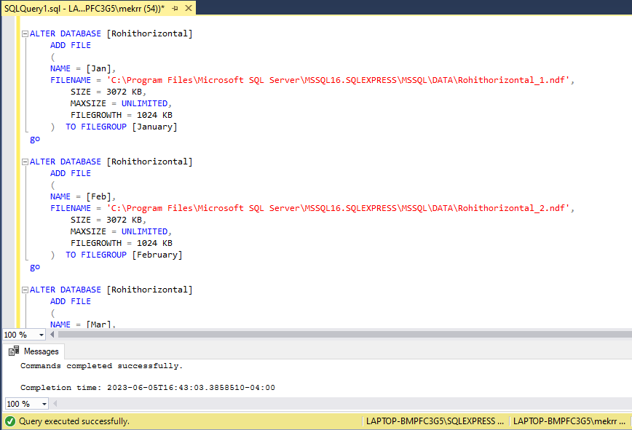

--To check files created added to the filegroups

SELECT

name as [FileName],

physical_name as [FilePath]

FROM sys.database_files

where type_desc = 'ROWS'

go

--4. Create a partition function <yourfirstname>ByMonth (Note: The datatype of the month to be integer)

CREATE PARTITION FUNCTION [RohitByMonth] (int)

AS RANGE RIGHT FOR VALUES (1, 2, 3, 4, 5, 6, 7, 8, 9, 10, 11, 12)

Go

--5. Create a partition scheme <yourfirstname>ByMonthADT

CREATE PARTITION SCHEME RohitByMonthADT

AS PARTITION RohitBymonth

TO (January, January, February, March,

April, May, June, July,

August, September, October,

November, December)

Go

--6. create or modify a table and specify the partition scheme as the storage location to segment the data out and store it within the appropriate file group.

CREATE TABLE BirthdayMonth

(Id int IDENTITY (1,1) NOT NULL,

BirthdayMonth int NOT NULL,

PRIMARY KEY (BirthdayMonth, Id))

ON RohitByMonthADT(BirthdayMonth);

Go

INSERT dbo.BirthdayMonth VALUES

(1),

(2),

(3),

(4),

(5),

(5),

(6),

(7),

(8),

(9),

(10),

(11),

(12)

GO

SELECT * from dbo.BirthdayMonth

GO

--7. Write a query to check the number of records in each partition.

SELECT $PARTITION.RohitByMonth(BirthdayMonth) AS Partition, COUNT(*) AS [COUNT] FROM dbo.BirthdayMonth

GROUP BY $PARTITION.RohitByMonth(BirthdayMonth) ORDER BY Partition

GO

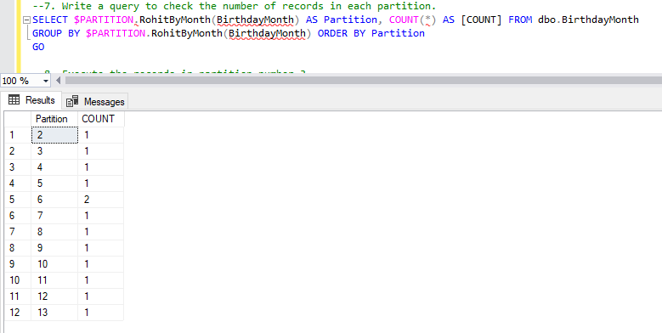

--8. Execute the records in partition number 3.

SELECT * FROM dbo.BirthdayMonth

WHERE $PARTITION.RohitByMonth(BirthdayMonth) = 3

Go

